The Effectiveness of the ***HadtisSoft* Application in Learning Hadith at the Department of Hadith Science, UIN Sayyid Ali Rahmatullah Tulungagung**



Shofwan Aljauhari 1 ,Mohammad Wildan Baihaqi 2 , Rifqi As'adah 3



|  |  |
| --- | --- |
| **\*Correspondent ce:**  Email: 1[eljauhar76@gmail.com](mailto:eljauhar76@gmail.com)  2[wildanbaiahaqi77@gmial.com](mailto:wildanbaiahaqi77@gmial.com)  3 [rifqialjauhari@gmail.com](mailto:rifqialjauhari@gmail.com) | **Abstract**  *In the throes of today's times, technology is always evolving. With the development of technology, all education must be able to keep up with its development. Especially the Department of Hadith. In education in the Department of Hadith Science, the text of the hadith can't change, because the text of the hadith must be connected to the Prophet Muhammad. But even so, the texts of the hadith are in various books. So the theory of digitization of hadith emerged, where the digitization of hadith is very necessary to maintain the trend of hadith in this day and age. In this article, researchers focus on one application*HaditsSoft*. Therefore, the author found several questions that became the first step in this study, namely, Agree that the*HaditsSoft*application is effective in its use as it can be used easily, quickly, and accurately. With these questions, researchers found that Hadith Science students of State Islamic University Sayyid Ali Rahmatullah already knew the application.*  ***Abstrak***  *Dalam pergolakan zaman saat ini, teknologi selalu berevolusi. Dengan berkembangnya teknologi membuat seluruh pendidikan harus dapat mengikuti perkembangannya. Khususnya jurusan Ilmu Hadis. Dalam pendidikan di jurusan Ilmu Hadis tidak mungkin teks hadis berubah-ubah, karena teks hadis harus tersambung kepada Nabi Muhammad. Namun walaupun demikian teks-teks hadis tersebut berada di berbagai kitab. Sehingga muncullah teori digitalisasi hadis, dimana digitalisasi hadis ini sangat diperlukan untuk menjaga tren hadis di zaman sekarang. Dalam artikel ini peneliti memfokuskan kedalam satu aplikasi HaditsSoft. Oleh karena itu peneliti menemukan beberapa pertanyaan yang menjadi langkah awal dalam penelitian ini yakni, Setujukah bahwa aplikasi HaditsSoft efektif dalam penggunaannya seperti dapat digunakan dengan mudah, cepat, dan akurat? Dengan pertanyaan-pertanyaan tersebut peneliti mendapatkan hasil bahwa mahasiswa Ilmu Hadis Universitas Islam Negeri Sayyid Ali Rahmatullah sudah mengenal aplikasi-aplikasi hadis tersebut, tentunya aplikasi HaditsSoft. Juga aplikasi HaditsSoft cukup efektif dalam membantu perkembangan pembelajaran di jurusan Ilmu Hadis Universitas Islam Negeri Sayyid Ali Rahmatullah Tulungagung. Dimana dari 13 responden yang telah dipastikan pernah menggunakan aplikasi HaditsSoft mengatakan bahwa 9 (69,2%) orang diantaranya mengatakan sangat setuju dengan kemudahan dan kecepatan aplikasi HaditsSoft, dan 4 (30,8%) diantaranya mengatakan sangat setuju dan 8 (61,5%) memngatakan cukup setuju dengan ketepatan teks hadis dalam dalam aplikasi HaditsSoft.* |
| **Author Affiliation:**  1 Institut Agama Islam Negeri Fattahul Muluk, Papua.  2 Universitas Islam Negeri Sayyid Ali Rahmatullah, Indonesia.  3 Universitas Islam Negeri Sayyid Ali Rahmatullah, Indonesia. |
| **Article History :**  Submission : Mounth Date, Years  Revised : Mount Date, Years  Accepted : Mount Date, Years  Published: Mountain Date, Years |
| **Keywords:** HadithSoft, Hadith Science, Learning, Effectiveness  ***Keywords:*** *HaditsSoft, Ilmu Hadis, Pembelajaran Efektivitas* |

**Introduction**



Every development of the age always brings up a variety of new things, in the present era the development of an era is identical to the evolution of a technology. The development of technology is largely determined by the invention of a media facility as a place of communication or exchange of information.[1] If described in writing, then technological advances start from the use of paper to the phone, to radio, to television, to computers, to smartphones.[2] With such technology is a good step to facilitate the search for information, online storage, learning, and so on.[3] Furthermore, technology is divided into two aspects that are one continuity, one of which is information technology, and communication.[4] Like this time when we contact someone else to be 24 hours faster.[5] So technology has a very important role as it can be used to access things from books to information easily, and does not require much space.[6] However, with the development of this technology, we also have to be careful in doing all kinds of things, as we always have to find out twice or more to get accurate information.



With the very rapid development of technology, this is progress that has been achieved by mankind which aims to make life easier to fulfill all life's needs.[7] So an activity emerged, namely digitizing hadith, where digitizing hadith itself is a very good evolution to keep hadith trends in line with the times. Where hadith digitization is the complete transfer of hadith texts to digital media such as HaditsSoft, Jawami al-Kalim, Maktabah Syamilah, Ensiklopedi Hadis, Lidwa Pustaka, and so on.[8] It is hoped that these applications can support the learning of hadith at this time. In this research, researchers focused on the Department of Hadith Science, Sayyid Ali Rahmatullah State Islamic University (UIN SATU)



As in research, there are 10 criteria in developing hadith software or applications, including 1) The hadith text must be complete from Sanad to Matan. 2) There is a translation of the hadith in it. 3) Include the source. 4) Understand the hadith. 5) Application or software creators are responsible and have the qualifications to create software or hadith applications. 6) Use of uncomplicated applications or software. 7) There is a hadith sanad mapping feature. 8) Create thematic hadith. 9) Placement of hadith based on the book title. 10) Providing cloth hadiths when there are hadiths of lower quality.[9]

In studying hadith science, hadith science has many methods and steps for researching a hadith. The first step is to carry out Takhrij Hadith or in Indonesian it means searching for hadiths. Where in many cases Takhrij Hadith information is activities to search for hadiths in their sources.[10] The Takhrij Hadith method, in short, is to search for a complete hadith from the sand to the mata in several main hadith books.[11] This method is also the beginning of all the steps in carrying out hadith research, so every researcher must carry out Takhrij Hadith to start his research, and continue with various steps in having hadith research. Such as looking at the quality of the hadith available, and finding out whether the biography of each narrator in the hadith has any defects, and comparing several similar hadiths with different qualities. With the very rapid development of technology, the Hadith Science department cannot afford to lose by just using ancient methods to perform Takhrij Hadith.



Therefore, it is hoped that these applications will help hadith researchers to make their research easier. These various applications contain complete hadiths, from Sanad to Matan. So with these applications, it can be seen that these applications are a wheel, which will bring the study of hadith science to develop and continue to exist in any era. If we look back, the method of searching for hadiths used by previous researchers was to search for keywords for the hadiths that were obtained and look for them in hadith books, which in one book can contain hundreds or even thousands of hadiths. Therefore, the role of these applications is very important in the current development of hadith. Even students of hadith science must be familiar with these applications to help the learning of hadith, and as a place for students to practice searching ( *Takhrij*) for hadith.

So, to keep up with technological developments, it is necessary to digitize hadith to keep up with current developments. Apart from that, following technological developments is also important to maintain the existence of hadith studies by digitizing hadith. Fathullah, who was a pioneer in digitizing hadith, also founded the PKH institution and has established several Hadith digitization products.[12]

There is an application called Lidwa Pustaka, where this application is a good response to following the flow of technological developments. This application can make it easier for researchers to carry out hadith research, especially in searching for a complete hadith from sanad to matan, even in this application there is criticism regarding the hadith that is being searched for.[13]

Therefore, to focus the discussion, the researcher chose one application, namely the *HaditsSoft application*. After trying to operate several hadith applications, the *HaditsSoft application*is an application that is very easy to operate compared to several other applications. So questions arise which are also problem formulations, including: What applications are often used by Hadith Science students at the Sayyid Ali Rahmatullah State Islamic University to support their learning? How does the *HaditsSoft*application work? What are the advantages and disadvantages of the *HaditsSoft application*? How effective is the *HaditsSoft application*in implementing learning in the Hadith Science department? From several of these questions, the researcher feels that this article is very important to maintain the trend of hadith science in the fierce development of technology. If this is allowed to happen, then gradually the study of hadith science will be forgotten by society, because the method of searching for hadiths using old methods is considered to be outdated in this day and age.



After explaining several things above, the researcher feels that this article plays an important role in knowing that students know all or some of these applications, knowing that students follow current technological developments so that they can operate one of these applications. The use of these applications in the development of learning in the Hadith Science study program, at Sayyid Ali Rahmatullah State Islamic University. Apart from that, with this article, the researcher hopes that with the current rapid technological developments, the Hadith Science study program with its discussion of hadith will remain a trend from now to the future.

­­­­

**Effectiveness Indicators**

Effectiveness itself can be seen from various points of view, where effectiveness itself is a change that can bring influence and benefits in using the *HaditsSoft application* in helping the development of learning in the Department of Hadith Science, Sayyid Ali Rahmatullah State Islamic University. [14]The concept of effectiveness itself is the achievement of agreed goals and objectives for the common good. where the achievement of a goal is determined by the sacrifices made by a group, while the level of effectiveness is determined by the goal itself.



Effectiveness is generally divided into three, namely individual effectiveness, group effectiveness, and organizational effectiveness. Individual effectiveness is the result of each individual in an organization. Group effectiveness is the contribution of members in an organization. Meanwhile, organizational effectiveness can obtain higher results because it contains individual and group effectiveness, to show the extent of the targets being achieved.

There is also another definition of effectiveness, where effectiveness is the utilization of resources, facilities, and infrastructure in a certain amount determined previously to produce goods for the services of the activities carried out. Where effectiveness is measured by how precisely the target is aimed at, the closer to the target, the higher the level of effectiveness.

Where in this article the effectiveness contained is the influence, and also the meaning of the HaditsSoft application in helping the development of hadith learning in the Hadith Science department of the Sayyid Ali Rahmatullah State Islamic University, Tulungagung. Where the scope is how accurate, how fast, and how easy it is to use the HaditsSoft application in helping the development of hadith learning in the Hadith Science department, Sayyid Ali Rahmatullah State Islamic University, Tulungagung.

**Trends in Hadith Digitization**

Hadith is a text which consists of various traditions that developed during the time of Rasulullah SAW. As is widely known, the Hadith itself is a reference to the personality of the Prophet, starting from the actions of the Prophet Muhammad, the sayings of the Prophet, and the provisions of the Prophet Muhammad.[15] As time goes by, hadith must be able to keep up with developments to maintain its trends. One of which is the digitization of Hadith.



The word digital comes from the Greek word "digitus" which means "finger". As is known, every human being has a pair of hands, and on those hands, there are 10 fingers. The number 10 consists of the numbers 1 and 0. So the numbers 1 and 0 or in the world of programming are often called "binary numbers" and are a depiction of digital itself which is composed of the numbers 1 and 0. These numbers are the basis of the programming language, namely as a database, and are often referred to as Bit (Binary Digit).[16] Digital itself is a concept whose understanding always develops in every era. So everything manual will evolve into automatic, and everything will become very concise.



Therefore, digital no longer requires human labor but tends to use automatic and sophisticated operating systems. Simply put, digital technology is just a calculating system that works very quickly and can process all forms of information using numerical values. For example, in analog technology, images and sounds are converted into radio waves. Meanwhile, in digital, images and sounds will be converted into numbers 1 and 0.[17] This is what makes everything automatic nowadays. So in the current era digital technology is very necessary to boost everything for the development of various things. For example, in the realm of learning, digital technology can summarize and simplify various things, starting from storage that no longer requires space, and is easier to use wherever we are.



In the current era, digital technology has developed very rapidly and can be seen in the evolution of Industry 4.0, where most industries develop and utilize existing technologies to simplify operations. Digital technology initially emerged in the 1980s, and that was also the beginning of the emergence of computers. At that time, the use of computers helped people to make it easier to search for information and access various issues circulating.[18] Until now, digital technology is still used as the same media as in 1980, including as a place to search for needed information, and search for issues that are often discussed, even today digital technology is often used as technology to develop a business.

Digital technology has its characteristics, as said by Lev Monovich, in his book entitled "The Language of New Media, Lev Manovich (2002)". Digital technology has five characteristics, namely numerical representation, modularity (the principle of assembling larger units from smaller ones), automation, variability, and transcoding (the relationship between computing and everyday culture). Apart from that, according to Lev Monvoich, digital technology is also closely related to various types of media, because media development always develops in every era.[19]



In the current era, namely the digital era, it is clear that technology has developed very, very rapidly. Until the emergence of the internet network, as a helper to search for information using a computer or even a cellphone. So that various types of media ranging from news in the form of newspapers, radio, and so on can be easier to use using a computer or cellphone. As a result, these media must also follow current technological developments so that these media continue to exist in the current era.[20]



In this era, many people have found people using digital media or system assistance. Even in learning, this technology is a very good breakthrough to simplify and develop information in learning. In this article, the lesson discussed is the science of hadith. So the science of hadith must indirectly follow current developments, namely by using currently available technologies. Therefore, it is very easy to find hadith texts using our cell phone or computer. Some of them can be found easily on several websites, or in the form of e-books in PDF format (Portable Document Format), there are even applications or software that contain hadith texts.[21]



In the science of hadith, to deal with current technological developments, there is still a lot that needs to be regulated, because there are thousands of hadith texts currently known, of various qualities, namely authentic, dhaif, and so on. Thus, digitizing hadith requires great attention. Starting from the information on hadith sanads, it must be complete from ancient hadith scholars until it is connected to the Prophet Muhammad sallallaahu 'alaihi wa sallam, information from narrators who narrated hadiths from friends, tabi'in, to today's famous figures such as Bukhari, Muslim , Tirmidhi, and so on.



So several very important criteria emerge in developing hadith applications or software, including The content of the hadith text must be complete from Sanad to Matan. There is a translation of the hadith in it. The source of the hadiths entered into the application or software must be clear. A brief understanding of hadith. The organization behind it that is responsible has the qualifications to create hadith software. Software that is friendly and easy to use by users. Has hadith sanad mapping. Create thematic hadith. Place the hadith based on the title of the book. Providing alternative hadiths when there are hadiths that are of lower quality.[22]

In other words, these criteria must be taken into account clearly when preparing an application, software, or website so that the sources shown can be used as references and can be accounted for. In general, digitizing hadith is an effort to maintain the trend of various hadith texts of the Prophet by following current developments. Especially in the current digital era, where everyone uses digital tools, hadith cannot be inferior to current technological developments. So the hadith must also follow and develop like this era. It is hoped that the digitization of this hadith can change and maintain the existence of the Prophet's hadith texts.

***HaditsSoft* application**

*HaditsSoft*application is an application that can be used on a laptop with a capacity of 281 MB and can be used online or offline. Apart from that, the *HaditsSoft application*is an application that is more or less similar to *the Ensiklopedi Hadits*of the Book of 9 Imams. However, this application has its advantages in its features, namely that it has added the level of hadith, and also added 5 books from the Kampungsunnah ebook, so the total number of books in the *HaditsSoft application is 14 books.*It would be good before continuing, researchers need to explain how HadtisSoft itself looks and how to operate it and its features.

The first step is to open the application on your respective laptop or computer.



Figure 1.1 Image of the *HaditsSoft application*

The image above is an image when the *HaditsSoft application* has been installed on a laptop or computer. After opening the application an image will appear like:

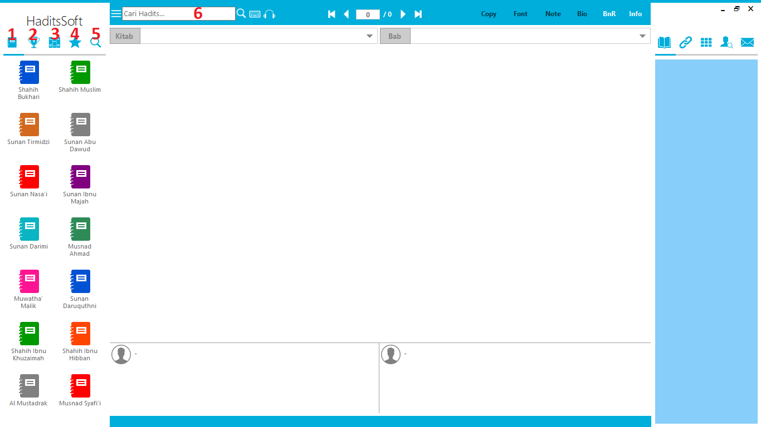

Figure 1.2 Initial display after opening the *HaditsSoft application*

The image above is the initial display after opening the *HaditsSoft application*. After opening the *HaditsSoft application*several options appear that can be used. As in the picture which has been numbered, the following is an explanation of these numbers.

1. First, there is a picture of a book containing a list of 14 books as explained above.
2. Second, there is a picture of a trophy, which is a list of the positions of hadiths, such as the Mutawatir hadith, Marfu' Hadith, Mauquf Hadith, and others.



1. Third, pictures of books arranged in rows whose contents are hadiths based on themes, where we can differentiate the hadiths according to their respective themes, such as worship, jihad, legal decisions, knowledge, faith, and so on.
2. Fourth, star images, as many people know, star images are usually a place to mark or bookmark.
3. Fifth, the magnifying glass image, this option can only be seen when using the search feature in the *HaditsSoft application*. Here the hadiths that are being searched for will be listed using the required keywords.
4. Sixth, is where we write keywords to find the hadith that we are looking for.

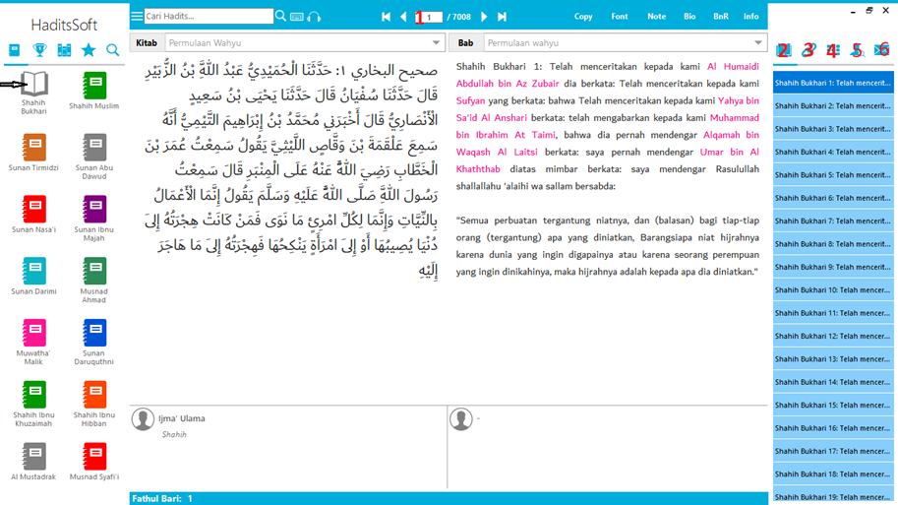

Picture 1.3 Display when choosing one of the 14 books

The picture above is the display when we have selected one of the books listed, namely 14 books. As in the example above, the researcher chose the Sahih Bukhari book like an arrow. In addition, when we have found a hadith we can see some other features as follows:

1. First, this is the total hadith found, or the total hadith in a book when choosing one of the books.
2. Second, is a list of hadiths from a book that has been selected. This feature can only be accessed and used when we choose one of the 14 books.
3. Third, is the chain of hadith, where when the feature is selected, the chain of narration will appear, starting from the narrator, up to the companions.
4. Fourth, is the same theme hadith feature, where when selected it will bring up hadiths that are similar to the hadiths that currently appear in the 2 middle columns in Arabic and Indonesian.
5. Fifth, there is a feature to search for the names of narrators if needed. With this feature, it is easier to find out the quality of each narrator.
6. Sixth, is the improvement report, as many people know, every application has some bugs, input errors, or something like that. So, this feature is a feature for reporting these errors so that they can be corrected by the application creator.

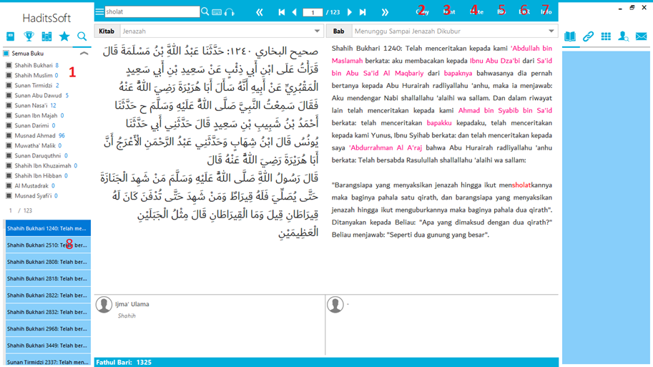

Figure 1.4 Display when searching for hadith using keywords

As shown in the picture, the researcher gave an example of searching for hadith texts with the keyword "prayer" and finally found a total of 123 hadiths that contained the word "prayer" in the hadith text. In the picture there are also numbers whose explanation is as follows:

1. First, it is the result of searching for hadiths in each book, as in the picture, 8 hadiths were found with the keyword "prayer" in the book Sahih Bukhari, and so on.



1. Second, this feature is a feature for copying the text of the hadith in it, either in Arabic or the Indonesian translation.



1. Third, the font feature, we can change the font in the application as we wish.
2. Fourth, the Note feature, as the Note itself says, this feature is a feature for us to make notes on the hadith listed in it.



1. Fifth, the Bio feature, contains complete biographies of several priests. These include a biography of Imam Bukhari, a biography of Imam Muslim, a biography of Imam Tirmidhi, and so on.
2. Sixth, the backup and restore feature, is simply called saving and restoring information that we have saved. For example, we have made notes to several hadiths that are being researched, we can save all the information that has been recorded, or hadiths that have been marked with the "bookmark" feature.



1. Seventh, this feature is a general information feature, such as sharing hadiths, hadith information that is rejected because the sanad contains notes, and so on.
2. Eighth, this feature makes it easier to search for hadiths because in this feature it shows what number of hadiths and in what books the same as the keywords used. However, after further investigation, this feature still has shortcomings, namely that it only looks like it is drawn, even though a total of 123 hadiths were found, only a few are listed in it. Even though it's like that, when directed one by one using the feature in the top center which has a right or left triangle shape, this feature will automatically scroll itself.

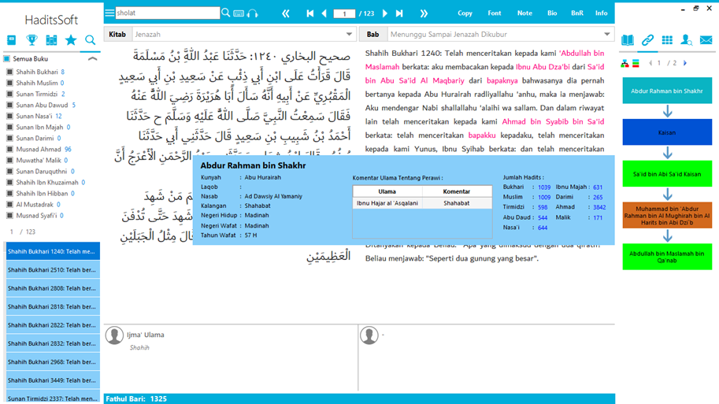

Figure 1.5 View of Sanad Hadith

The picture above shows that we can see whether the transmission path is connected to the prophet, it can also be used to see the comments of the scholars from each narrator in the hadith listed in the middle, whether the narrator has any defects or not. Apart from that, you can also find out the name of the narrator (nickname or nickname), the title of the narrator (*laqob*), the lineage of the narrator, the circle of the narrator, where the narrator lives, where the narrator died, and the year the narrator died.



**Research result**

With the help of a Google form, researchers conducted a survey aimed at UIN SATU Hadith Science study program students from semester 5 to alumni. In the questionnaire, the researcher included the core questions, namely:

1. Can the existence of hadith applications help the development of hadith learning at this time? Explain!
2. What is your opinion regarding the *HaditsSoft application*?
3. Do you agree that the *HaditsSoft application* can be used easily?
4. Do you agree that the *HaditsSoft application* can be applied quickly?
5. Do you agree that the *HaditsSoft application* is as accurate as other hadith texts?

However, before discussing the five questions, we will first explain the background of each respondent, starting from what semester the respondent is in, in what semester the respondent received material regarding hadith applications, what applications the respondent knows, what applications the respondent often uses and how according to them regarding the applications they often use.

Of the 36 respondents who responded, the researcher will explain everything in sentence form. Where of the 36 respondents there were 10 respondents from semester 5, 15 respondents from semester 7, and 11 respondents were alumni of the Hadith Science department. A total of 35 respondents had received material discussing hadith applications, while 1 of them had never received material on hadith applications.

Of the 36 respondents, 13 students received material on hadith applications in semester 4, 11 students received material on hadith applications in semester 3, 4 students received material on hadith applications in semester 5, 4 students received material on hadith applications in semester 6, 2 students got material on hadith applications in semester 2, and 2 other students forgot which semester they got material on hadith applications.

To ensure that every student knows several types of hadith applications, the researcher also lists what hadith applications the students know. With multiple choice, 29 (80.6%) students knew the *HaditsSoft application*, 23 (63.9%) students knew the *Jawami al-Kalim application*, 26 (72.2%) students knew the *Maktabah Syamilah application*, 28 (77.8% ) students know *the Ensiklopedi Haditsapplication*, 1 (2.8%) student knows the Mausu'ah al-Haditsiyyah application, 1 (2.8%) student knows the hadith text from the website, 1 (2.8%) student knows the application in dorar.net website, and search for hadiths, 1 (2.8%) students know all these applications. So it can be said that the majority of students know the *HaditsSoft application*.

To find out what applications are often used by students, researchers also included the question "From the several applications above, name one application that you often use in the practice of searching for hadiths? Explain the advantages compared to other software!”. This question is a paragraph in nature so the researcher will explain it in sentence form that is easy to understand. 16 students often use the *HaditsSoft application*, 15 students use the *Jawami al-Kalim application, 11 students use the Ensiklopedi Hadits*application, 2 students use *Maktabah Syamilah*, 1 student uses get hadith, 1 student uses dorar.net, and 1 student who has not used any hadith application. Among all these answers, quite a lot of students used two applications quite often, the most frequently found were the applications *HaditsSoft*, *Jawami al-Kalim*, and *Ensiklopedi Hadits*.

In general, the majority of students still frequently use the *HaditsSoft application*. According to respondents, the *HaditsSoft application*has its advantages, namely that it includes hadith books from 9 Imams, can be used offline, making it easier to use the application, and in searching for hadiths, there is an assessment of hadiths and a short biography of each narrator, light, simple, features which is complete, takes up less storage space than other applications, in the *HaditsSoft application*there is an Indonesian translation, suitable for helping beginner *Takhrij Hadith writers*. Meanwhile, the drawback is that the numbering of hadiths is not like in books, such as in the *Jawami al-Kalim application*, or *Maktabah Syamilah*.

*The Jawami al-Kalim*application, the advantage according to respondents is that it is more detailed and has more complete information compared to the *HaditsSoft application*in terms of *Takhrij Hadith,*jarh wa ta'dil, and syarh

because it clearly states the source of the hadith from which book, it is not complicated and is simpler, the results The search is more complex than other applications, more complete, there are more of them than other applications. The disadvantage is that there is no translation like in *HaditsSoft*.

Ensiklopedi Hadits Application, the advantages according to respondents is that it is easier and more accurate, easy to search for hadiths, simple and effective, easier to use because it is in Indonesian, can be accessed via cellphone or computer, the series of sanads are easier to understand, the application is easy to get because it can be installed via Google Play Store. Meanwhile, the drawback is that there are only 9 Imam books, unlike HaditsSoft which has 14 books.



Maktabah Syamilah application, the advantage according to respondents is that the sanad in this application is complete so it is easy to find out who the sanad are in each hadith, 90% match the original book. Lastly is the Get Hadith website, and Dorar.net, where the dorar.net ranks sanad is not very complete, only the rawi al-a'la and mukharij are shown, and there are differences in the numbering of the hadith. Meanwhile, according to respondents, the Get Hadith website is easier and more practical.

Next, the researcher will describe the answers from the respondents to the core questions listed previously. The first question "Can the existence of hadith applications help the development of hadith at this time? Explain!". Of the 36 respondents agreed with this statement. According to the respondents, because nowadays various things are online-based, the hadith application is very necessary to make it easier to search (Takhrij ) the hadith texts they want wherever and whenever concerning the books that are listed in the hadith application.

In the development of hadith digitization itself, hadith applications are very necessary, because hadith applications have a big role in the scientific development of hadith science itself and can also help students to carry out searches ( Takhrij ) of hadiths to research a hadith. Some of them may have difficulty finding hadiths by manually searching in the books one by one or even don't have hadith books, because the hadith books themselves are difficult to find and quite expensive for students, so with the hadith application they can help students as well as ordinary people to shorten the time in searching ( Takhrij ) for hadiths. Because this application is based on two languages, namely Indonesian and Arabic, with this language base, in searching for complete hadiths, ordinary people can also use this application to search for complete hadiths circulating in technological media, because as technology users, they must ensure that the information they obtain does not contain elements of hoax or fraud. Therefore, it is hoped that this application can help reduce hoax information.



Apart from that, due to differences in time, hadith researchers currently cannot meet directly with hadith transmitters, so the help of this application can track the hadith, narrated by whom, and in what book. For students or people who cannot read Arabic pegon, this application can help users because it includes translations of the hadiths they are looking for. Even with the hadith application, there may be some users who are interested in studying hadith, knowing the qualities of hadith because of the easy search system. In this way, the development of hadith will become more widespread because people already understand the use of this application. However, as a researcher, he also confirmed it at least a second time directly in his book. Because most of the numbering applications do not match the original book. As with many printing businesses that have their publications, the hadith numbers remain the same, but the pages are sometimes different from those listed on the application. Therefore, it would be good for a researcher to check a second time with the books he has so that the information can be taken seriously.



By using the help of the hadith application, students, the public, or researchers can use the hadith application for the first step, a very important step, namely searching ( Takhrij ) of hadiths, because before conducting research, a researcher is required to know the complete hadith from the Sanad to the Matan. The first search, what is done is to look for all the hadiths whose discussion is the same as the hadith that is being searched for, then check again in the hadith books to strengthen the hadith that is being searched for, and finally research the hadith. It is hoped that with the help of the hadith application, can facilitate practice in learning to search for hadiths ( Takhrij ) hadiths. If not, the science of hadith will increasingly lag behind the times, and over time it will likely become less and less interesting because the manual method is very complicated and takes a lot of time.



Second Question "What is your opinion regarding the HaditsSoft application ?" This application can help and make it easier for students to search for ( Takhrij ) hadiths, moreover, the HaditsSoft application is easier to access even though there is no internet network on the computer, with various features in it that make it easier to use the HaditsSoft application. It also contains quite complete data starting from the completeness of the sanad to the matan, the chain of connected sanads to the prophet's companions, and short biographies of each narrator. The application is not too large, and the content is also quite complete compared to other hadith applications, there is keyboard assistance in the application if Arabic is not installed on the computer. Unlike other hadith applications, the HaditsSoft application has its characteristics, namely that there is an Indonesian translation and quite complete information about the quality of the hadith that is being sought. However, among the advantages of the HaditsSoft application, this application also has disadvantages, namely that sometimes there are errors, the numbering of hadiths does not match the original book, so further developments need to be made to make it easier to use this application. The impact of the numbering of hadiths, which sometimes do not match, makes many researchers have to check again with the books they own and see whether the hadiths listed are the same or not. Therefore, the HaditsSoft application must be found out again about whose book the book was published as a reference so that it is easier to use the .



For the third to fifth questions, the researcher focused more on several students from semester 7 and above, and several from semester 5 who the researcher had confirmed were able to use hadith applications. Where in semester 7 and above it can be confirmed that they have carried out hadith research, and use the help of existing hadith applications. From the Google Form that had been distributed, the researchers got 13 respondents. The third question "Do you agree that the HaditsSoft application can be used easily?" Of the 13 respondents, 9 (69.2%) of them chose strongly agree, and 4 (30.8%) of them chose quite agree.

The fourth question "Do you agree that the *HaditsSoft application* is applied quickly?" Of the 13 respondents, 9 (69.2%) of them chose strongly agree, and 4 (30.8%) of them chose quite agree. The fifth and final question "Do you agree that the *HaditsSoft application* has similar hadith text accuracy to several other applications?" Of the 13 respondents, 4 (30.8%) chose strongly agree, 8 (61.5%) chose quite agree, and 1 (7.7%) chose not to agree.

Apart from the responses obtained with the help of Google Forms, researchers also conducted experiments using two different applications, namely the HaditsSoft application, and the Jawami al-Kalim application. With the hadiths found on the website with the keyword "prayer and finally the researcher found a website, among others, https://www.orami.co.id/magazine/hadis-tangan-salat. Where on the website there are several hadiths, therefore, the researcher took one example of hadith and applied it to the two applications. The hadith text taken as an example is:



سَأَلْتُ رَسُولَ اللَّهِ صَلَّى اللَّهُ عَلَيْهِ وَسَلَّمَ: أَيُّ الْعَمَلِ أفضل؟ قال: «الصلاة في وَقْتِهَا» . قُلْتُ: ثُمَّ أَيٌّ؟ قَالَ: «الْجِهَادُ فِي سَبِيلِ اللَّهِ» . قُلْتُ: ثُمَّ أَيٌّ؟ قَالَ «بِرُّ الْوَالِدَيْنِ» ، قَالَ: حَدَّثَنِي بِهِنَّ رَسُولُ اللَّهِ صَلَّى اللَّهُ عَلَيْهِ وسلم ولو استزدته لزادني

*Meaning: "I once asked the Messenger of God, "What is the most important deed?" He replied, "Doing the prayer at its time." I said again, Then what else?" He replied, "Strive in the way of God." I asked again, "Then what else?" He replied, "Devoted to both parents." Ibn Mas'ud said, "All that was told to me by the Prophet SAW. If I had asked for more information, he would have added it."*

From the hadith above, researchers can easily search for hadiths in the HaditsSoft application, where they can easily find the hadith in the HaditsSoft application in just 3 minutes. Meanwhile, in the Jawami al-Kalim application, the researcher tried to search using various existing keywords, and searched for quite a long time, including more than 6 minutes, still not finding the hadith that was being searched for. Because in the Jawami al-Kalim application, everything is in Arabic, and searches are also in Arabic, while HaditsSoft can be searched using Indonesian.

Therefore, the *HaditsSoft application* is easier and faster to use to search for hadiths. However, for accuracy, researchers can say that 50% of them in the *HaditsSoft application* are quite accurate, the same as the information obtained in the previous Google Form. Because there are only 14 hadith books contained in it, for information regarding each narrator the comments from scholars are still incomplete regarding which book it comes from. Because it is known that up to now there are hundreds of books that discuss this matter.

Apart from that, each application has its advantages and disadvantages. In the HaditsSoft application, a very striking deficiency is that the application is rarely updated, such as on a website including [https://archive.org/details/Setup HaditsSoft](https://archive.org/details/SetupHaditsSoft), which is a website that contains information about the HaditsSoft application, the last upload was June 16, 2016. Due to its nature which can be used offline, the HaditsSoft application should continue to update its features so that it can catch up with other applications.



HaditsSoft application is that it can help Hadith Science students who are new to Hadith, or students who are not from an Islamic boarding school background, and whose Arabic language is still below average. Because in the HaditsSoft application, there is an Indonesian translation feature, and you can search in Indonesian. Meanwhile, the entire Jawami al-Kalim application is in Arabic, and searches must be in Arabic, you must find keywords that match the hadith in the Jawami al-Kalim application.

**Conclusion**

From the information obtained above, it can be said that all students of Hadith Science at Sayyid Ali Rahmatullah State Islamic University are certain to be familiar with hadith applications, especially the HaditsSoft application which is expected to help make it easier to carry out hadith research, in the first step in searching for hadiths ( Takhrij Hadis ) and assist in the development of hadith learning today. However, because the applications created are humans, there are advantages and disadvantages, and the advantages of the HaditsSoft application that are very striking are the speed and ease of use of the HaditsSoft application compared to other applications. However, the accuracy of the hadith can be said to be 50% accurate, because there are only 14 book references, while the information regarding the comments of the scholars is not accompanied by the name of the book. This has been proven by several students of hadith science who have conducted their research using HaditsSoft quite often to help make searching for hadiths easier. There was even a direct trial of using two applications between HaditsSoft and Jawami al-Kalim. Using the HaditsSoft application is easier to use compared to the Jawami al-Kalim application.

Based on the information obtained, researchers can conclude the respondents above, starting from semester 5 onwards. They quite often use the HadtisSoft application, to help carry out hadith research. However, although there are many advantages to the HaditsSoft application, there are also disadvantages. The suggestion from researchers for the HaditsSoft application is that the HaditsSoft application must continue to be upgraded in several ways, starting from making the references clearer, including what books the ulama come from, and cross-checking the numbering of the hadiths again.

**Bibliography**

Ahmad, Khader. “DIGITALISASI HADITH DI MALAYSIA ANALISIS TERHADAP KEPERLUAN KRITERIA PEMBANGUNAN WEBSITE DAN SOFTWARE HADITH,” 2019, 331–52. https://www.utusan.com.my/bisnes/ekonomi/bagaimana-media-digital-memberi-.

Aji, Rustam. “DIGITALISASI, ERA TANTANGAN MEDIA (Analisis Kritis Kesiapan Fakultas Dakwah Dan Komunikasi Menyongsong Era Digital).” *Islamic Communication Journal* 1, no. 1 (2016): 43–54. https://doi.org/10.21580/icj.2016.1.1.1245.

Akbar, Amin, and Nia Noviani. “TANTANGAN DAN SOLUSI DALAM PERKEMBANGAN TEKNOLOGI PENDIDIKAN DI INDONESIA.” *Prosiding Seminar Nasional Pendidikan Program Pascasarjana Universitas Pgri Palembang*, 2019, 18–25.

Akmaluddin, Muhammad. “Sanad Digital: Ijazah Hadis Musalsal Dalam Kajian Hadis Virtual Di Grup Dan Halaman Facebook.” *Nabawi: Journal of Hadith Studies* 2, no. 1 (2021): 141–61. https://doi.org/10.55987/njhs.v2i1.44.

Ansori, Aan. “DIGITALISASI EKONOMI SYARIAH.” *ISLAMICONOMIC: Jurnal Ekonomi Keuangan Dan Bisnis Islam* 7, no. 1 (2016): 1–18. https://doi.org/10.32678/ijei.v7i1.33.

Aspi, Muhammad, and Syahrani. “PROFESIONAL GURU DALAM MENGHADAPI TANTANGAN PERKEMBANGAN TEKNOLOGI PENDIDIKAN.” *ADIBA: JOURNAL OF EDUCATION* 2, no. 1 (2022): 64–73.

Danuri, Muhamad. “PERKEMBANGAN DAN TRANSFORMASI TEKNOLOGI DIGITAL.” *Infokam* XV, no. II (2019): 116–23.

Fakhrurrazi. “Hakikat Pembelajaran Yang Efektif.” *Jurnal At-Tafkir* 11, no. 1 (2018): 85–99. https://doi.org/10.32505/at.v11i1.529.

Fikriyyah, Dilya Ul. “Telaah Aplikasi Hadis (Lidwa Pusaka).” *Jurnal Studi Ilmu-Ilmu Al-Qur’an Dan Hadis* 17, no. 2 (2016): 273–88.

Hadi, Rahmad Tri. “Studi Aplikasi Hadis Era Mobile.” *Islam Transformatif : Journal of Islamic Studies* 4, no. 1 (2020): 13–24. https://doi.org/10.30983/it.v4i1.2629.

Himmah, Tsania Nahdiatul, and Dyah Sitoresmi Fitri Azisi. “PENGARUH PERKEMBANGAN TEKNOLOGI INFORMASI TERHADAP LAYANAN PERPUSTAKAAN IAIN TULUNGAGUNG.” *BIBLIOTIKA : Jurnal Kajian Perpustakaan Dan Informasi* 3, no. 2 (2019): 123–30. http://journal2.um.ac.id/index.php/bibliotika.

Huda, Irkham Abdaul. “Perkembangan Teknologi Informasi Dan Komunikasi (TIK) Terhadap Kualitas Pembelajaran Di Sekolah Dasar.” Jurnal Pendidikan Dan Konseling (JPDK) 2, no. 1 (2020): 121–25.

Jendri. “Pola Pemahaman Hadis Partisipan Kegiatan One Day One Hadis Dalam Whatsapp.” *Islam Transformatif : Journal of Islamic Studies* 4, no. 1 (2020): 1–12. https://doi.org/10.30983/it.v4i1.2661.

Nurfalah, Irfan, and Aam Slamet Rusydiana. “DIGITALISASI KEUANGAN SYARIAH MENUJU KEUANGAN INKLUSIF: KERANGKA MAQASHID SYARIAH.” *Ekspansi: Jurnal Ekonomi, Keuangan, Perbankan Dan Akuntansi* 11, no. 1 (2019): 55–76. https://doi.org/10.35313/ekspansi.v11i1.1205.

Rahmatullah. “AHMAD LUTFI FATHULLAH DAN DIGITALISASI HADITH DI NUSANTARA.” *Islamica: Jurnal Studi Keislaman* 14, no. 2 (2020): 291–316. http://dx.doi.org/10.1016/j.ndteint.2014.07.001%0Ahttps://doi.org/10.1016/j.ndteint.2017.12.003%0Ahttp://dx.doi.org/10.1016/j.matdes.2017.02.024.

Rohimah, Afifatur. “Era Digitalisasi Media Pemasaran Online Dalam Gugurnya Pasar Ritel Konvensional.” *KANAL: Jurnal Ilmu Komunikasi* 6, no. 2 (2018): 91–100. https://doi.org/10.21070/kanal.v6i2.1931.

Sagala, Azan. “Takhrij Hadis Dan Metode-Metodenya.” *Al-Ulum: Jurnal Pendidikan Islam* 2, no. 2 (2021): 83–96. https://doi.org/10.30596/al-ulum.v.

Ummah, Siti Syamsiyatul. “DIGITALISASI HADIS (Studi Hadis Di Era Digital).” *Diroyah: Jurnal Ilmu Hadis* 4, no. 1 (2019): 1–10.

Yoga, Salman. “PERUBAHAN SOSIAL BUDAYA MASYARAKAT INDONESIA DAN PERKEMBANGAN TEKNOLOGI KOMUNIKASI.” *Jurnal Al-Bayan* 24, no. 1 (2018): 29–46. https://doi.org/10.22373/albayan.v24i1.3175.

Yusuf, Bistari Basuni. “Konsep Dan Indikator Pembelajaran Efektif.” *Jurnal Kajian Pembelajaran Dan Keilmuan*, 2017.

1. Tsania Nahdiatul Himmah and Dyah Sitoresmi Fitri Azisi, "PENGARUH PERKEMBANGAN TEKNOLOGI INFORMASI TERHADAP LAYANAN PERPUSTAKAAN IAIN TULUNGAGUNG," *BIBLIOTIKA : Jurnal Kajian Perpustakaan Dan Informasi* 3, no. 2 (2019): 123–30, http://journal2.um.ac.id/index.php/bibliotika.
2. Muhamad Danuri, "PERKEMBANGAN DAN TRANSFORMASI TEKNOLOGI DIGITAL," *Infokam* XV, no. II (2019): 116–23.
3. Muhammad Aspi and Syahrani, "PROFESIONAL GURU DALAM MENGHADAPI TANTANGAN PERKEMBANGAN TEKNOLOGI PENDIDIKAN," *ADIBA: JOURNAL OF EDUCATION* 2, no. 1 (2022): 64–73.
4. Irkham Abdaul Huda, "Perkembangan Teknologi Informasi Dan omunitas (TIK) Terhadap Kualitas Pembelajaran Di Sekolah Dasar," *Journal of Education and Counseling (JPDK)* 2, no. 1 (2020): 121–25.
5. Salman Yoga, “PERUBAHAN SOSIAL BUDAYA MASYARAKAT INDONESIA DAN PERKEMBANGAN TEKNOLOGI KOMUNIKASI,” Jurnal Al-Bayan 24, no. 1 (2018): 29–46, https://doi.org/10.22373/albayan.v24i1.3175.
6. Amin Akbar and Nia Noviani, “TANTANGAN DAN SOLUSI DALAM PERKEMBANGAN TEKNOLOGI PENDIDIKAN DI INDONESIA,” *Prosiding Seminar Nasional Pendidikan Program Pascasarjana Universitas Pgri Palembang*, 2019, 18–25.
7. Rahmad Tri Hadi, “Studi Aplikasi Hadis Era Mobile,” *Islam Transformatif : Journal of Islamic Studies* 4, no. 1 (2020): 13–24, https://doi.org/10.30983/it.v4i1.2629.
8. Muhammad Akmaluddin, “Sanad Digital: Ijazah Hadis Musalsal Dalam Kajian Hadis Virtual Di Grup Dan Halaman Facebook,” *Nabawi: Journal of Hadith Studies* 2, no. 1 (2021): 141–61, https://doi.org/10.55987/njhs.v2i1.44.
9. Khader Ahmad, “DIGITALISASI HADITH DI MALAYSIA ANALISIS TERHADAP KEPERLUAN KRITERIA PEMBANGUNAN WEBSITE DAN SOFTWARE HADITH,” 2019, 331–52, https://www.utusan.com.my/bisnes/ekonomi/bagaimana-media-digital-memberi-.
10. Azan Sagala, “*Takhrij* Hadis Dan Metode-Metodenya,” *Al-Ulum: Jurnal Pendidikan Islam* 2, no. 2 (2021): 83–96, https://doi.org/10.30596/al-ulum.v.
11. Siti Syamsiyatul Ummah, “DIGITALISASI HADIS (Studi Hadis Di Era Digital),” *Diroyah: Jurnal Ilmu Hadis* 4, no. 1 (2019): 1–10.
12. Rahmatullah, “AHMAD LUTFI FATHULLAH DAN DIGITALISASI HADITH DI NUSANTARA,” *Islamica: Jurnal Studi Keislaman* 14, no. 2 (2020): 291–316, http://dx.doi.org/10.1016/j.ndteint.2014.07.001%0Ahttps://doi.org/10.1016/j.ndteint.2017.12.003%0Ahttp://dx.doi.org/10.1016/j.matdes.2017.02.024.
13. Dilya Ul Fikriyyah, “Telaah Aplikasi Hadis (Lidwa Pusaka),” *Jurnal Studi Ilmu-Ilmu Al-Qur’an Dan Hadis* 17, no. 2 (2016): 273–88.
14. Fakhrurrazi, “Hakikat Pembelajaran Yang Efektif,” *Jurnal At-Tafkir* 11, no. 1 (2018): 85–99, https://doi.org/10.32505/at.v11i1.529.
15. Jendri, “Pola Pemahaman Hadis Partisipan Kegiatan One Day One Hadis Dalam Whatsapp,” *Islam Transformatif : Journal of Islamic Studies* 4, no. 1 (2020): 1–12, https://doi.org/10.30983/it.v4i1.2661.
16. Rustam Aji, “DIGITALISASI, ERA TANTANGAN MEDIA (Analisis Kritis Kesiapan Fakultas Dakwah Dan Komunikasi Menyongsong Era Digital),” *Islamic Communication Journal* 1, no. 1 (2016): 43–54, https://doi.org/10.21580/icj.2016.1.1.1245.
17. Aan Ansori, “DIGITALISASI EKONOMI SYARIAH,” *ISLAMICONOMIC: Jurnal Ekonomi Keuangan Dan Bisnis Islam* 7, no. 1 (2016): 1–18, https://doi.org/10.32678/ijei.v7i1.33.
18. Irfan Nurfalah and Aam Slamet Rusydiana, “DIGITALISASI KEUANGAN SYARIAH MENUJU KEUANGAN INKLUSIF: KERANGKA MAQASHID SYARIAH,” *Ekspansi: Jurnal Ekonomi, Keuangan, Perbankan Dan Akuntansi* 11, no. 1 (2019): 55–76, https://doi.org/10.35313/ekspansi.v11i1.1205.
19. Aji, “DIGITALISASI, ERA TANTANGAN MEDIA (Analisis Kritis Kesiapan Fakultas Dakwah Dan Komunikasi Menyongsong Era Digital).”
20. Afifatur Rohimah, “Era Digitalisasi Media Pemasaran Online Dalam Gugurnya Pasar Ritel Konvensional,” *KANAL: Jurnal Ilmu Komunikasi* 6, no. 2 (2018): 91–100, https://doi.org/10.21070/kanal.v6i2.1931.
21. Rahmatullah, “AHMAD LUTFI FATHULLAH DAN DIGITALISASI HADITH DI NUSANTARA.”
22. Ahmad, “DIGITALISASI HADITH DI MALAYSIA ANALISIS TERHADAP KEPERLUAN KRITERIA PEMBANGUNAN WEBSITE DAN SOFTWARE HADITH.”